Name: | _______________SOLUTIONS__________________________ |  |  |  |  | Date: ___________
 | Subject - Year 9 Mathematics  Investigation 2, 2013  Topic – Perimeter & Area  In class component |  |  |  |  | 47  = %
Total Time: | 60 minutes
Reading Time: | 5 minutes
Working Time: | 55 minutes
Weighting: | ______% of the year.
Equipment: | Scientific Calculator
Date out: |  | Week ____ Date _____________ |  | Date Due: | Week ____ Date _____________
Assignment weighting: |  | **% of the year
AIM: In this assessment, you will be investigating area and perimeter for simple and compound shapes.
There are two parts to this assessment:
Item | Purpose | Marks available
Take-Home | To expand your knowledge and skill with Perimeter and Area. | 5
In-Class | To test your knowledge and skill with Perimeter and Area. | 42

This In-Class part is to be completed at in class and you have one session to complete it. It will be run under exam conditions, in the same manner as exams and assessments in future years, in order that you become accustomed to them.

You are permitted the following:
- One A4 Sheet of notes (front and back)
- A scientific calculator
- Normal writing instruments
You will not be permitted to borrow equipment from others during the assessment.

You are not permitted to use your Take-Home part in the In-Class Verification

Please make sure you are using the appropriate units and show your working. In order to get maximum marks on this assignment you must show working and use the correct units.

Mark collection
Question | Marks available | Marks achieved
1 | 1
2 | 3
3 | 3
4 | 6
5 | 1
6 | 4
7 | 2
8 | 3
9 | 3
10 | 5
11 | 5
12 | 6
Take home | 5
Total | 47

SECTION A: PERIMETER

1 | Perimeter of a circle [1 mark]
Calculate the length of the perimeter of a circle of diameter 30cm

Perimeter = 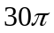cm or 94.25 cm 

2 | Perimeter of a semi-circle [3 marks]  Calculate the size of the perimeter of a semi-circle having a radius of 7cm  Curved section = 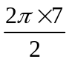cm = 21.99 cm   Straight section = 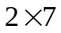cm = 14 cm   Perimeter = 21.99 cm + 14 cm = 35.99 cm 
3 | Perimeter of a quarter circle [3 marks]  Calculate the perimeter of a quarter circle with a diameter of 16 cm  Curved section = 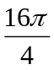cm = 12.57 cm   Straight section = 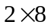cm = 16 cm   Perimeter = 12.57 cm +16 cm = 28.57 cm 
4 | Perimeter of a part circle [6 marks 3, 3]  - Describe how you would calculate the perimeter of a 45 degree section out of a circle of radius 5m.  Calculate the length of the curved section using 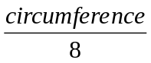or 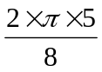m   Calculate the length of the straight sections using 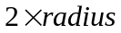or 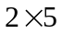m   Add the two together   - Now do the calculation  Curved section = 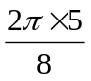cm = 3.93 cm   Straight section = cm = 10 cm   Perimeter = 3.93 cm + 10 cm = 13.93 cm 
5 | Perimeter of a scalene triangle [1 mark]  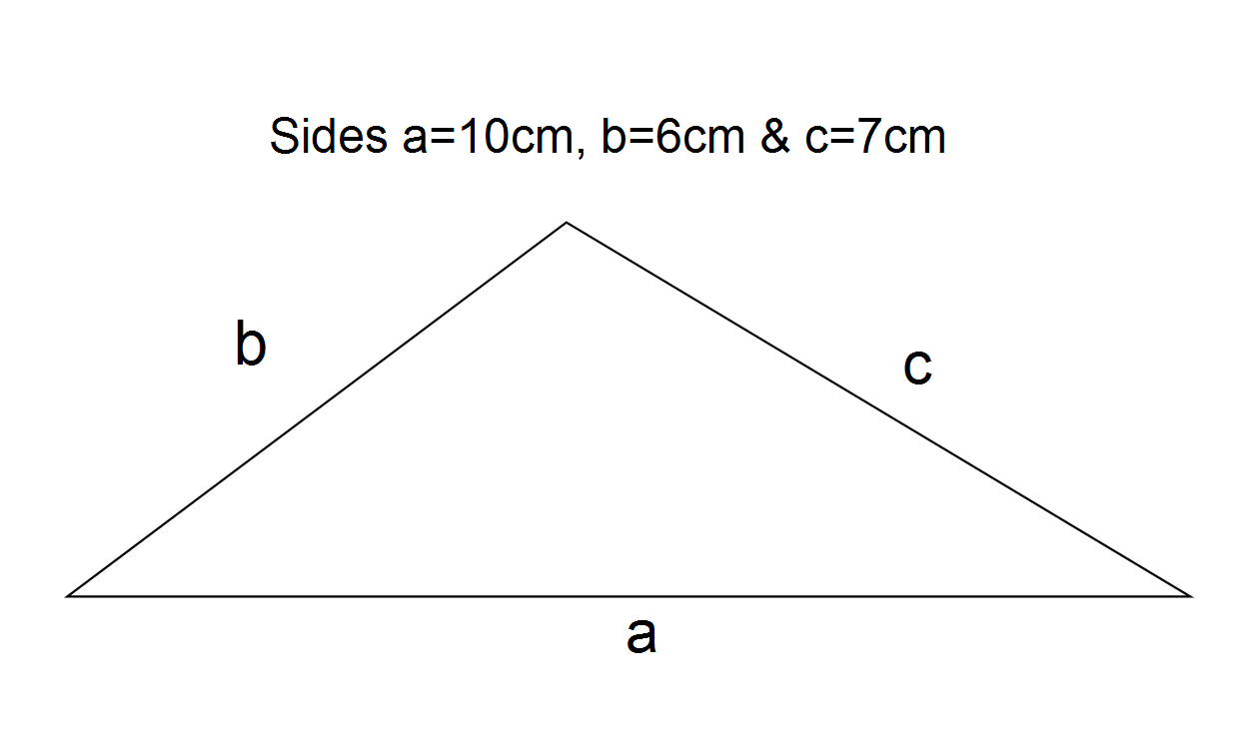  Calculate the size of the perimeter  Perimeter = 10 + 6 + 7 = 23 cm 
6. | A non-scalene triangle [4 marks 2, 2]  - Describe how would you calculate the perimeter of a triangle with all 3 sides 8 m?  Multiply the length of one side by three   - Now perform the calculation  Perimeter = 3 x 8m = 24 m 

SECTION B: AREA

7. | Area of a circle [2 marks]
Calculate the area of a circle 20km wide

Area = 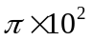km² 

= 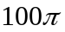km² or 314.16 km² 

8. | Area of a semi-circle [3 marks]
Calculate the area of a semi-circle having a radius of 70mm

Area = 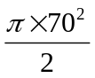mm² 
= 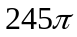mm² or 769.69 mm² 

9. | Area of a quarter circle [3 marks]
Calculate the area of a circle of diameter 50cm with a quarter removed.

Full circle area = 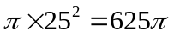= 1963.50 cm2 
Area removed =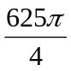= 490.87 cm2 
Area left = 1963.50 - 490.87 = 1472.62 cm2 

or

Area = 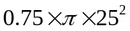 
= 1472.62 cm2 

10. | Area of part of a circle [5 marks: 2, 3]
- Describe how would you calculate the area of a 45 degree piece of a pie of diameter 30cm?

Calculate the area of a circle with diameter 30cm

Using 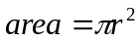

Divide the answer by 8

- Now do the calculation:
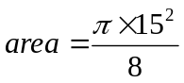

= 88.36 cm²

11. | Area of a triangle [ 5 Marks: 2, 3]
 | Calculate the area of the following:
 | a) Non-right angled triangle  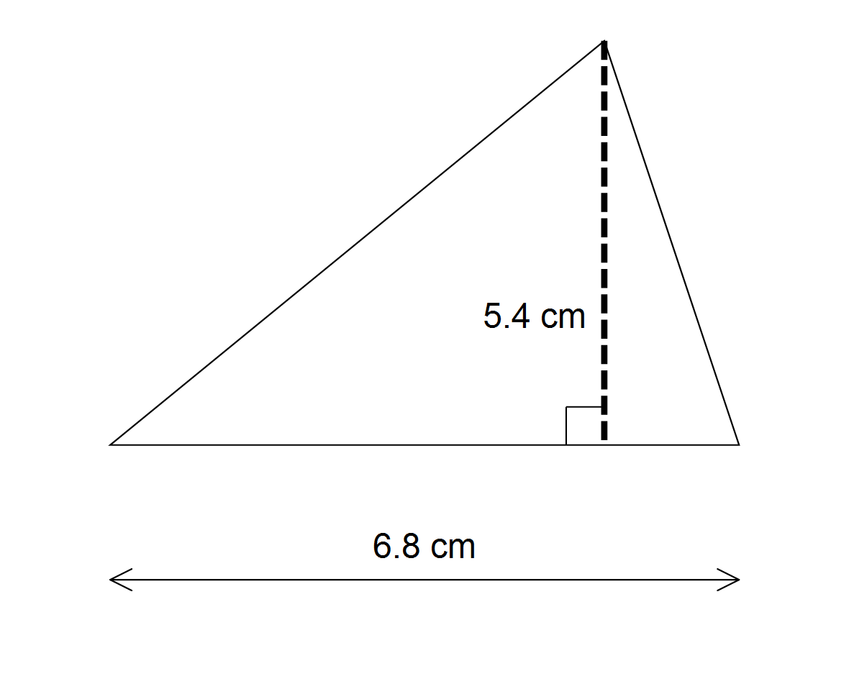  Area = 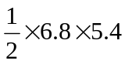   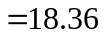 cm²  | b)Right angled triangle  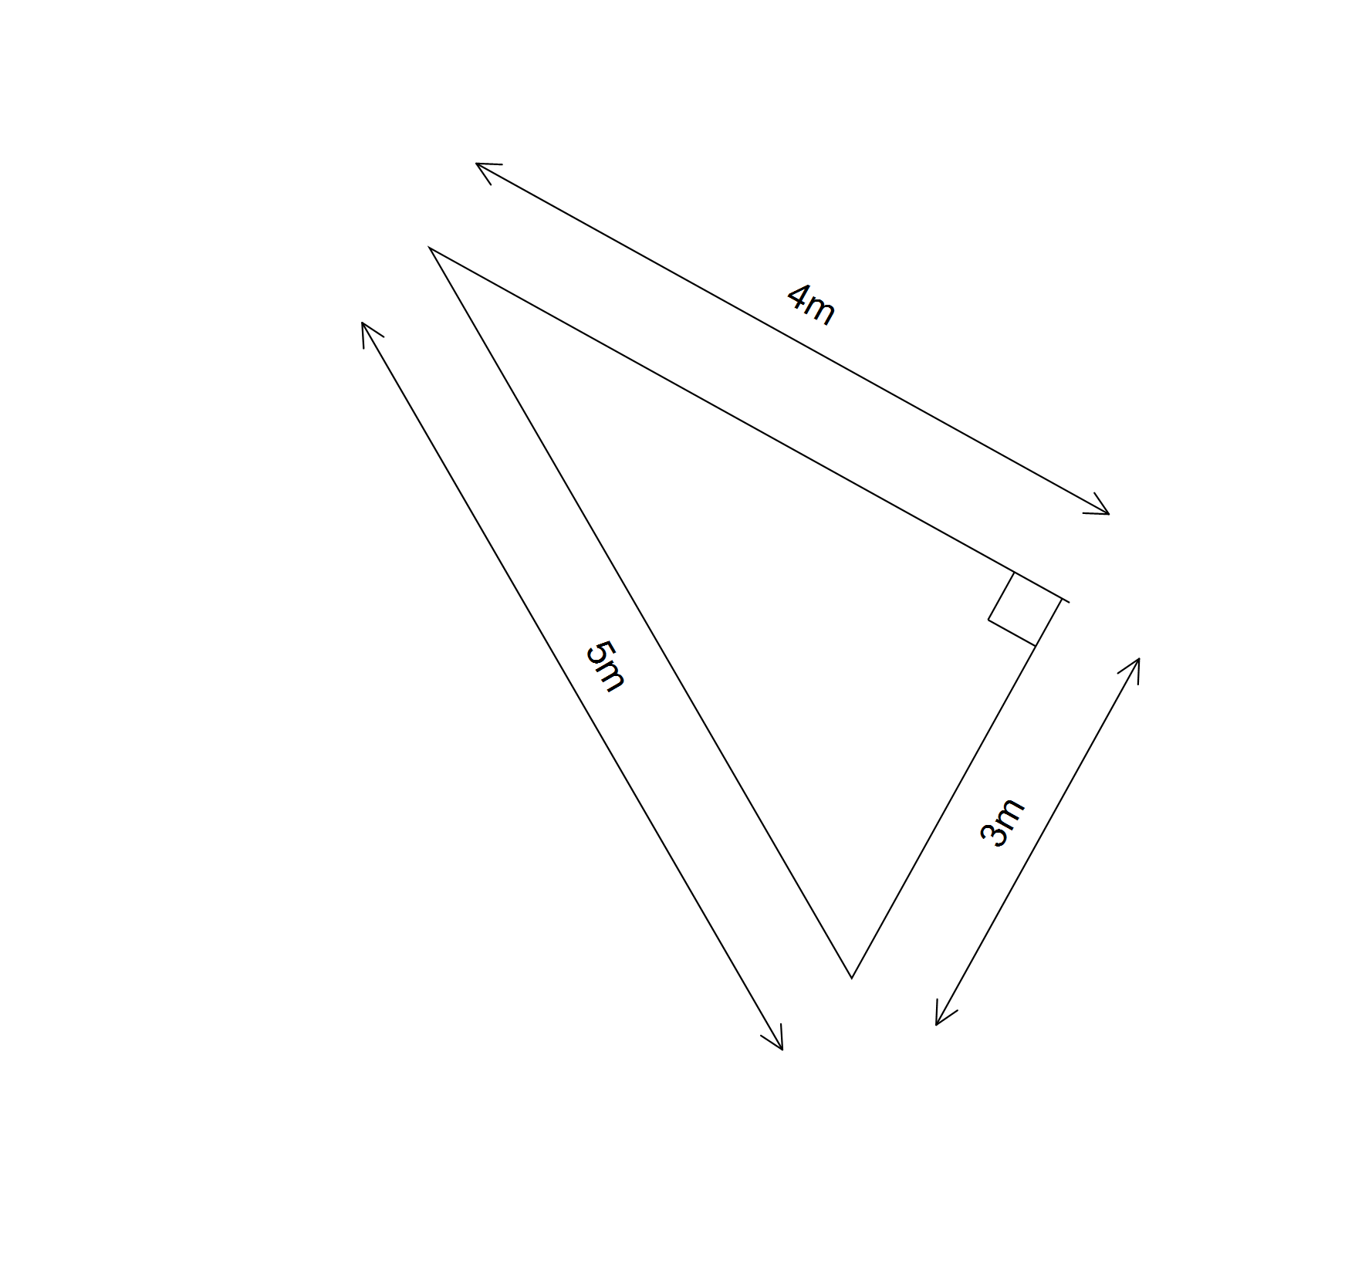  Area = 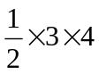   = 6 m² 

12. | Area of a triangle using Herons Formula [6 marks: 5, 1]
Use Heron's formula to calculate the area of a triangle with sides 3m, 5m & 4m

Perimeter 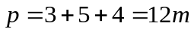 
Semi-perimeter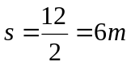 
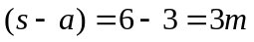,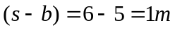 and 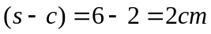 



Step 5: The area of the triangle = 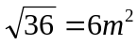 

Compare your answer to that in 10 b). What do you notice?

The two answers are the same 

